

Verification DOCUMENT

Verification Plan



July 22, 2025

Mirafra TECHNOLOGY

**INDEX**

|  |  |
| --- | --- |
| **Contents** | **Page No.** |
| **Chapter 1 Design Overview** | **2** |
| **Chapter 2 Verification Architecture** | **7** |
|  |  |
|  |  |
|  |  |

**CHAPTER 1 – DESIGN OVERVIEW**

1. **ALU:**

An **Arithmetic Logic Unit (ALU)** is a crucial digital circuit within a processor that performs both arithmetic operations, such as addition and subtraction, and logic operations like AND, OR, and XOR on binary data. Acting as the “computational core” of the CPU, the ALU directly executes the mathematical and logical instructions required by programs, enabling the processor to process and manipulate data. Its design typically includes multiplexers and logic gates that select and implement the desired operation based on control signals. The efficiency and capability of the ALU largely influence the overall speed and performance of a computing system.

* 1. **Advantages of ALU**
* Enables high-speed execution of arithmetic and logic operations.
* Supports multiple operations (addition, subtraction, bitwise logic) within a single unit.
* Compact design allows integration into CPUs, microcontrollers, and digital systems.
* Contributes to the programmability and flexibility of digital devices.
* Reduces the need for external computation hardware.
  1. **Disadvantages of ALU**
* Limited to fixed, pre-designed operations and cannot easily adapt to specialized tasks.
* Complex ALU designs increase area and power consumption in hardware.
* Higher bit-width ALUs add latency, affecting overall system speed.
* Some arithmetic operations like division or floating-point computation require additional dedicated units.
  1. **Use cases of ALU**
* Central part of CPUs and digital signal processors (DSPs) for data processing.
* Used in embedded systems and microcontrollers for sensor data computation.
* Key component in programmable logic controllers (PLCs) and automation systems.
* Employed in cryptography and graphics processors for fast bit manipulation.
* Integral to scientific calculators and digital measurement instruments.
  1. **Project Overview of ALU**
* This project focuses on designing a fully parameterized, multi-functional Arithmetic Logic Unit (ALU) that can perform a wide range of arithmetic and logical operations based on configurable command inputs. The ALU accepts two parameterized-width operands (OPA and OPB), and supports addition, subtraction, increment, decrement, comparison, multiplication with pre-processing (e.g., increment or shift before multiply), as well as advanced logical functions including AND, OR, NAND, NOR, XOR, XNOR, bitwise NOT, and shifting operations.
* It includes specialized rotate operations (ROL_A_B and ROR_A_B) whose behavior depends on specific patterns in OPB, and incorporates built-in error detection when illegal operand patterns are encountered. The design features synchronous operation controlled by a clock (CLK), asynchronous reset (RST), and an active-high clock enable (CE) to manage data flow. The ALU differentiates between arithmetic and logical operations using the MODE input and validates operands based on INP_VALID.
* The outputs include the computed result (RES), status flags for overflow (OFLOW), carry out (COUT), and comparator flags (G, L, E), along with an error flag (ERR) to indicate invalid rotate conditions. This design demonstrates the integration of arithmetic computation, logical operations, comparator functions, and error handling into a single configurable ALU module suitable for digital processing applications, verification exercises, or as a reusable IP block in complex SoC designs.
  1. **Design Features**

|  |  |  |  |  |
| --- | --- | --- | --- | --- |
| **Serial no** | **Pin name** | **Direction** | **No of bits** | **Function** |
| 1 | OPA | INPUT | Parametrized | Parameterized operand 1 |
| 2 | OPB | INPUT | Parametrized | Parameterized operand 2 |
| 3 | CIN | INPUT | 1 | This is the active high carry in input signal of 1-bit |
| 4 | CLK | INPUT | 1 | This is the clock signal to the design and it is edge sensitive |
| 5 | RST | INPUT | 1 | This is the active high asynchronous reset to the design |
| 6 | CE | INPUT | 1 | This is the active high clock enable signal 1-bit |
| 7 | MODE | INPUT | 1 | MODE signal 1 bit is high, then this is an Arithmetic Operation; otherwise, it is a Logical Operation |
| 8 | INP_VALID | INPUT | 2 | Operands are valid as per below table: 00: No operand is valid01: Operand A is valid10: Operand B is valid |

|  |  |  |  |  |
| --- | --- | --- | --- | --- |
| **Serial no** | **Pin name** | **Direction** | **No of bits** | **Function** |
| 10 | RES | OUT | Parameterized +1 | This is the total parameterized plus 1 bits result of the instruction performed by the ALU |
| 11 | OFLOW | OUT | 1 | This 1-bit signal indicates an output overflow during Addition/Subtraction |
| 12 | COUT | OUT | 1 | This is the carry out signal of 1-bit during Addition/Subtraction |
| 13 | G | OUT | 1 | This is the comparator output of 1-bit which indicates that the value of OPA is greater than the value of OPB |
| 14 | L | OUT | 1 | This is the comparator output of 1-bit which indicates that the value of OPA is less than the value of OPB |
| 15 | E | OUT | 1 | This is the comparator output of 1-bit which indicates that the value of OPA is equal to the value of OPB |
| 16 | ERR | OUT | 1 | When CMD is selected as 12 or 13 and mode is logical operation, if 4th, 5th, 6th, and 7th bits of OPB are 1, then ERR bit will be 1; else it is high impedance |

* 1. **Design Limitation**
* Supports only a fixed set of predefined arithmetic and logical operations; adding new operations requires design modification.
* Limited operand width defined by parameterization; very wide operands may increase area and reduce speed.
* Rotate operations (ROL_A_B and ROR_A_B) depend on specific operand patterns, and invalid patterns produce an error instead of a predictable fallback result.
* Comparator outputs (G, L, E) are based on unsigned comparison only; signed comparison is not supported.
* No built-in support for complex operations like division, modulo, or full multiplication beyond pre-processed multiply.
* Error flag (ERR) is specific to rotate commands and does not capture other types of functional errors or overflow in logical mode.
* The design is synchronous and edge-sensitive, so glitches or metastability issues may occur if inputs violate setup/hold requirements.
* No pipelining or parallel execution; performance may be limited in high-speed applications where multiple operations must be processed simultaneously.
  1. **Interfaces**

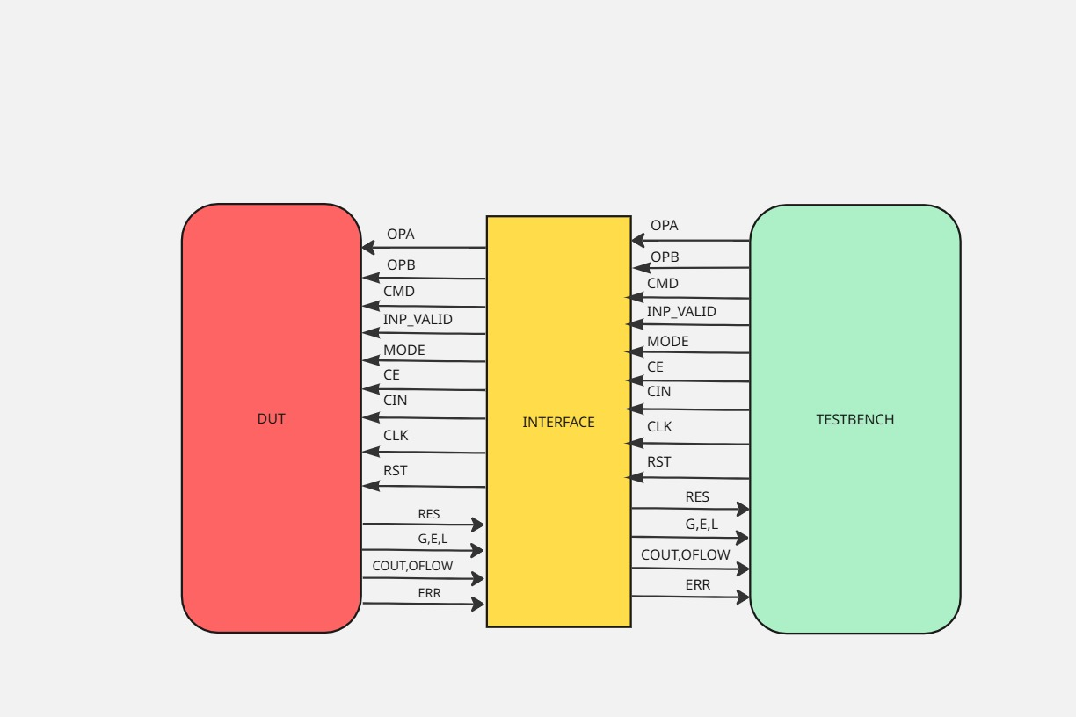

|  |  |  |  |
| --- | --- | --- | --- |
| **Signal Name** | **Direction (in clocking block)** | **Bit Width / Size** | **Description** |
| OPA | output | WIDTH bits | Operand A |
| OPB | output | WIDTH bits | Operand B |
| CMD | output | CMD_WIDTH bits | Operation command |
| IN_VALID | output | 2 bits | Indicates which operands are valid |
| MODE | output | 1 bit | Arithmetic (1) or logical (0) mode |
| CE | output | 1 bit | Clock enable |
| CIN | output | 1 bit | Carry-in input |

**-Driver interface**

-**Monitor Interface**

|  |  |  |  |
| --- | --- | --- | --- |
| **Signal Name** | **Direction (in clocking block)** | **Bit Width / Size** | **Description** |
| RES | input | WIDTH + 1 bits | Result of ALU operation |
| ERR | input | 1 bit | Error flag for illegal rotate etc. |
| OFLOW | input | 1 bit | Overflow flag |
| COUT | input | 1 bit | Carry-out flag |
| G | input | 1 bit | Comparator: OPA > OPB |
| E | input | 1 bit | Comparator: OPA == OPB |
| L | input | 1 bit | Comparator: OPA < OPB |

-**Reference Interface**

|  |  |  |  |
| --- | --- | --- | --- |
| **Signal Name** | **Direction (in clocking block)** | **Bit Width / Size** | **Description** |
| OPA | input | WIDTH bits | Operand A |
| OPB | input | WIDTH bits | Operand B |
| CMD | input | CMD_WIDTH bits | Operation command |
| IN_VALID | input | 2 bits | Indicates which operands are valid |
| MODE | input | 1 bit | Arithmetic or logical mode |
| CE | input | 1 bit | Clock enable |
| CIN | input | 1 bit | Carry-in input |

**Chapter 2 – VERIFICATION ARCHITECTURE**

1. 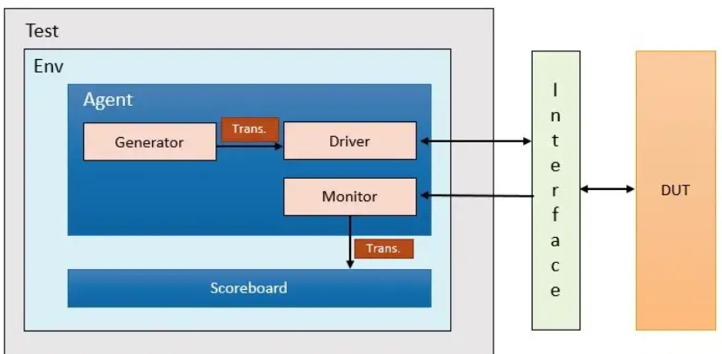**Verification Architecture**
   1. **Verification Architecture for ALU**

* 1. **Flow-Chart for each component**

1. **Transaction**

* Represents a single set of inputs and expected outputs for the ALU.
* Typically includes fields like OPA, OPB, CMD, MODE, IN_VALID, etc.
* Acts as the *data carrier* between generator, driver, monitor, and scoreboard.
* Designed as a System Verilog class with randomization support for constrained-random testing.
* Generator generates all the randomized fields from transaction

1. **Generator**

* Generates randomized or directed transaction objects.
* Controls the sequence of inputs to cover different ALU operations (add, sub, logical ops, rotate, etc.).
* May implement constraints to focus on interesting corner cases like overflow, carry, and invalid rotate conditions.
* Feeds transactions to the driver through a mailbox.

1. **Driver**

* Drives input signals from a transaction onto the DUT interface (via virtual interface).
* Reads fields like OPA, OPB, CMD, etc., from the transaction and assigns them to interface signals.
* Synchronizes with the DUT using clocking blocks and follows proper handshake protocols.
* Translates abstract transactions into actual pin-level activity on the DUT.
* Driver sends the data to reference model using the mailbox.

1. **Monitor**

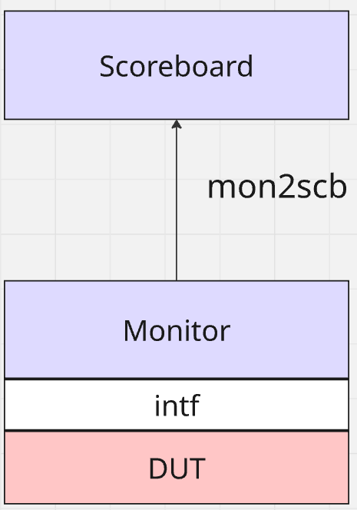

* Passively observes DUT inputs and outputs via the interface.
* Captures actual values of result (RES), flags (COUT, OFLOW, ERR), and comparator outputs (G, E, L).
* Creates new transactions or analysis data based on observed DUT behaviour.
* Sends captured data to the scoreboard for checking.

1. **Interface**

* The Alu_interface groups all DUT input and output signals into a single structured block, improving readability and maintainability.
* Clocking blocks (Drv_cb, Mon_cb, Ref_cb) inside the interface define timing and direction for driver, monitor, and reference, ensuring correct sampling and driving with respect to the clock.
* The **virtual interface** acts as a dynamic handle, allowing verification components (driver, monitor, reference model) to access the DUT signals indirectly.
* Using a virtual interface keeps the testbench modular and reusable, making it easier to swap DUT instances or change the environment without modifying component code.
* It enables consistent and synchronized communication between the DUT and verification components, simplifying the design of complex testbenches.

1. 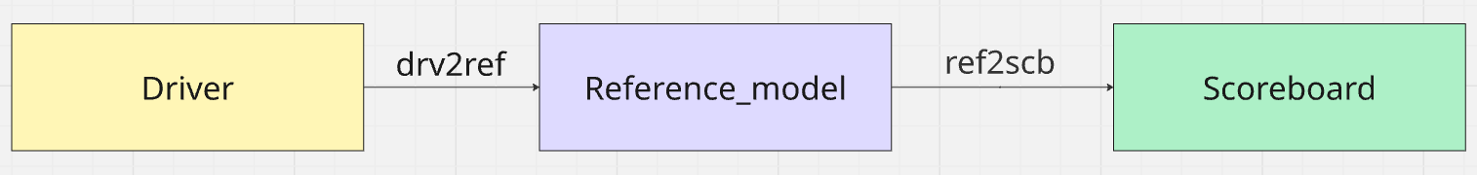**Reference Model**

* The reference model is a *golden model* that predicts the correct output of the ALU based on given inputs (OPA, OPB, CMD, MODE, etc.).
* It usually runs in parallel with the DUT during simulation, receiving the same inputs via the interface or virtual interface.
* The predicted results from the reference model are sent to the scoreboard to be compared against the actual DUT outputs (RES, COUT, OFLOW, etc.).
* Helps ensure functional correctness by detecting mismatches between expected and actual behavior.
* Acts as an independent, high-level behavioral model, making it easier to debug and isolate DUT design bugs.

1. 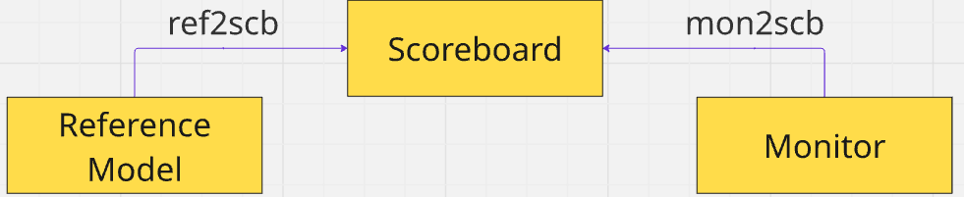**Scoreboard**

* Receives expected transactions from generator (or reference model) and actual results from the monitor.
* Compares DUT outputs with expected values, considering corner cases like overflow, carry, or illegal commands.
* Logs mismatches and issues error reports if DUT behaviour doesn’t match expectations.
* Helps measure functional correctness and coverage of the ALU.